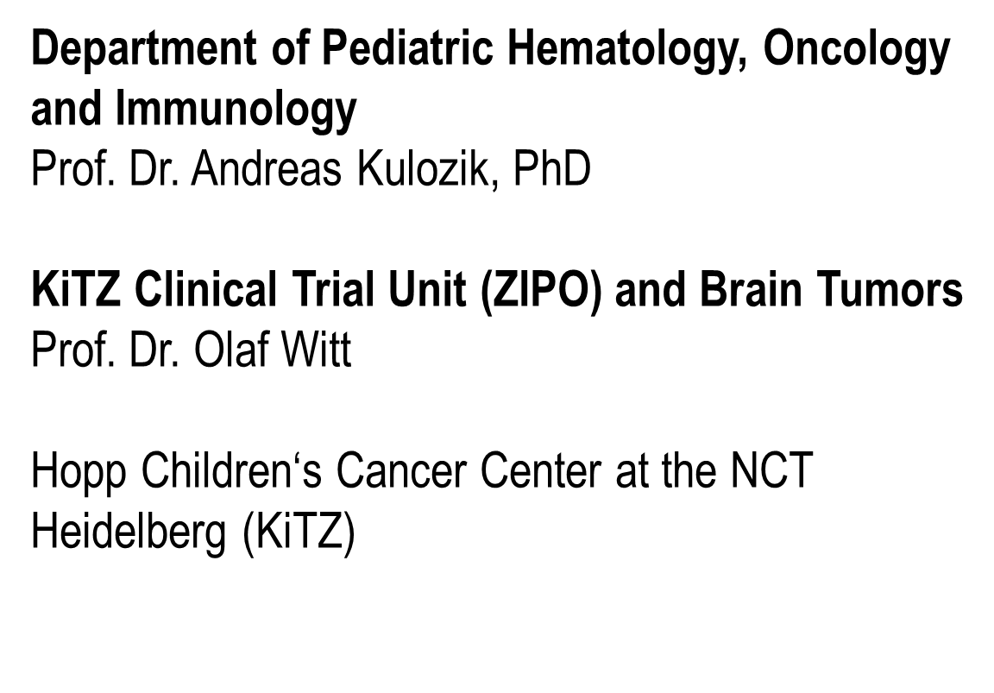
PTT2.0

Information on Changes due to the EU General Data Protection Regulation

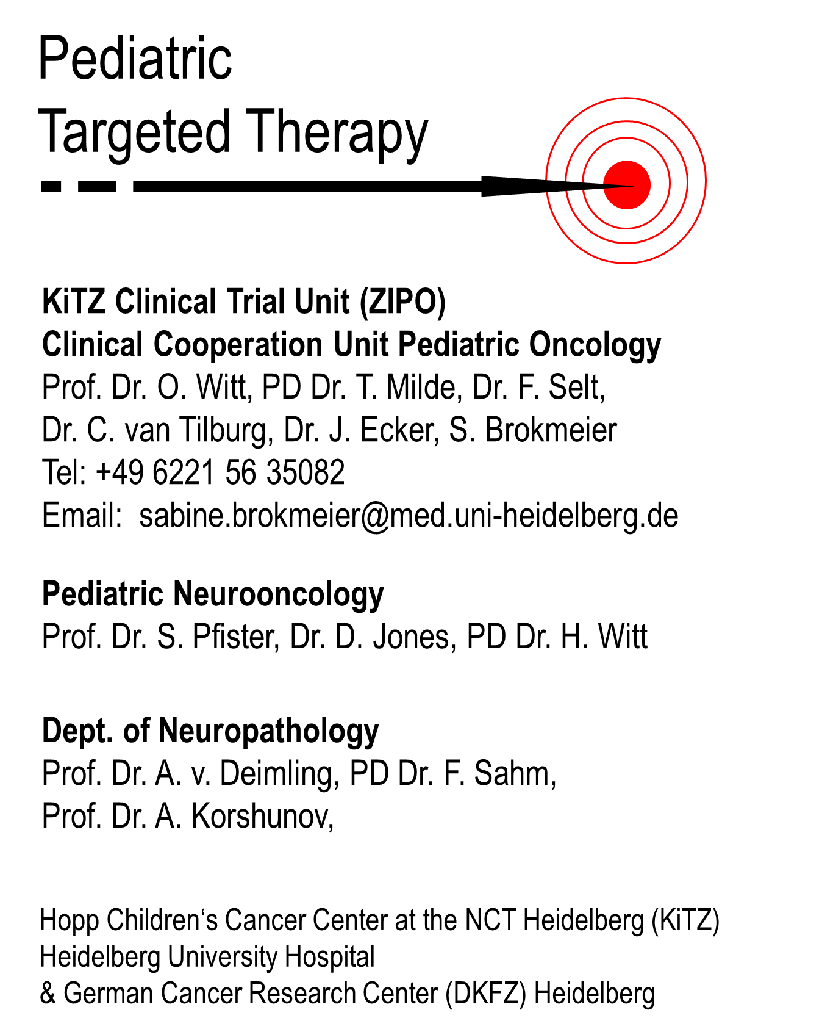
„Pediatric Targeted Therapy 2.0“ - refining diagnosis and analyzing targets in progressive and relapsed pediatric malignancies

The mutually agreed General Data Protection Regulation (EU-GDPR; https://www.eugdpr.org/) came into force on 2018 May 25th. The informed consent of the PTT2.0 registry already fulfills important requirements. Furthermore we are obliged to inform you about the following:

Responsible for processing of data is the principal investigator PD. Dr. Till Milde.

Data protection officer of PI’s institution:
Datenschutzbeauftragter des Universitätsklinikums Heidelberg
Im Neuenheimer Feld 672
69120 Heidelberg
06221 56-7036 (AB)
datenschutz@med.uni-heidelberg.de

Data protection officer responsible for your trial site
[Please insert name of the data protection officer of your institution with contact information]

If you suspect, that during data collection and / or data processing of personal data the data protection has been violated, you can complain at the local data protection authority.

Local Data Protection Authority (DPA) responsible for the Principal Investigator:

Der Landesbeauftragte für den Datenschutz und die Informationsfreiheit Baden-Württemberg
Königstraße 10a
70173 Stuttgart
Telefon: 0711 615541-0
Fax: 0711 615541-15
E-Mail: poststelle@lfdi.bwl.de
Internet: https://www.baden-wuerttemberg.datenschutz.de

You can find your National Data Protection Authority online:
http://ec.europa.eu/justice/article-29/structure/data-protection-authorities/index_en.htm

Rights of data subject:
- to obtain from the data controller confirmation as to whether or not personal data concerning him or her is being processed, where and for what purpose. The controller shall provide a copy of the personal data, free of charge, in an electronic format (Article 15 GDPR).
- to rectification (Article 16 GDPR) if necessary.
- to erasure (Article 17 GDPR); shall not apply to the extent that processing is necessary for archiving purposes in scientific research purposes in accordance with Article 89
- to restriction of processing (Article 18, GDPR)
to transmit that data to another controller (Article 20 GDPR).
- withdraw consent to the use of data beyond the purposes of the project

